2014-2015

Welcome Package 2016-17

Welcome to the Huron-Perth Lakers!
Congratulations on being selected to represent a Lakers AAA Team for the 2016-2017hockey season. This is our 20th year and we hope it will be our best yet!
This Welcome Package has been put together to work in conjunction with our Tryout Package to deliver important information about our organization to our membership. This package also provides your family with important fundraising information and tools to help in the process of gathering sponsors, etc. Please read both packages carefully as they should be able to answer the most common questions asked about our Association.
In this Welcome Package you will find a letter from the President of the Lakers organization. This letter will help introduce you to potential sponsors and recognize you as a Huron Perth Lakers 2016-2017 season player.
Please review the Fundraising and Sponsorship Program. In reference to the Banner and the Player webpage it is important that you complete your involvement and submit to your team Managers by the appropriate dates.
Cheques by your sponsors are made payable to your team’s account name. The Fundraising and Sponsorship programs assist you with the costs associated with registration, tournaments, referees, etc throughout the season.
We are excited to kick off our season in Stratford when the Lakers host our 3rd Annual OHL Exhibition Game Fundraiser at the Allman arena. Several teams will have a league games that day in Stratford to help support this very exciting organizational fundraiser. We hope that all members plan to attend this game, and bring a friend or two!
Laker Day will be on October 29th in St Marys. Every team will play a league game on this day. Lakers gear will be available for you to purchase and we will have team 50/50 draws.
Important Dates
July 1st - Submit Practice Sweater Sponsorships to Dunny’s
August 1st. – Deadline for gathering Team Banner sponsorships
August 25th – Submit Webpage Team and Player sponsors to Webmaster.
October29th – Lakers Day in St Marys
January 13-15th - 5th Annual GLC
Our fifth Annual Great Lakes Cup will be held in Stratford January 13-15th for Minor Pee Wee and Minor Bantams teams from across North America. Come out to support the Lakers and this tournament. It is a major fundraiser for our organization.
Please encourage family and friends to attend your games all year and cheer on the Lakers. There is “No Gate Fee” admission to Alliance Hockey League or post-season hockey games.
The Lakers Executive holds monthly meetings to manage and assess the organization's progress. These meetings will be posted on the website. All members are welcome to attend.
In closing, the Executive welcomes you to our AAA Hockey Club. We hope that you share and exemplify the PRIDE of being a Laker Player. We wish you every success in this upcoming season with your Lakers Team.
Welcome to the Lakers 20th Season!

Player Fundraising Initiatives
The Huron-Perth Lakers AAA Minor Hockey Association is pleased to provide fundraising initiatives for each player signed with the Huron-Perth Lakers. Fundraising participation is totally optional, but they do allow participating members to recoup a significant amount of the cost of playing AAA hockey. To the best of our knowledge we are the only AAA organization providing this level of opportunity to our members!!

BANNER SPONSORS
Players can solicit a MAXIMUM of 4 Banner Sponsors. Each banner sponsorship is sold for a minimum amount of $250. If your sponsor is willing to give more that is great, however $250 is the minimum for a space on the team banner. Through this Banner Sponsor Program each player can realize a potential of $1000 with 100% of the money retained by the player in his/her team account. Banner advertising must be completed and submitted to the team Manager before August 1st. Each team will have a person responsible to collect these. See page 3

PLAYER WEBPAGE SPONSORS
Each player will have a webpage linked to their name on the team Roster on the HPL website which contains space for up to 13- $60 ads or a combination of ad spaces that can generate $780 towards your hockey season. Ad spaces can be supported by local businesses, family or service clubs. Sponsor's business websites can have a link from the players page to the business. Your team webmaster will require a business card from your sponsor.
Webpage sponsors are collected and submitted to the Team Webmaster no later than August 25th. They can be uploaded by the webmaster as they are received which allows you to show your sponsors your player page with a very short turnaround. Cheques should be given to your team treasurer to be added to your players account within the team account.

What if we DON’T Want to Collect Sponsorships?
If your family chooses to not participate in collecting sponsors and/or fundraising that is your choice. It is not a requirement however it offers you the opportunity to offset some of the costs of playing AAA hockey.
There is an expectation that each player will have adequate funds in their team account to cover their portion of the team expenses (ie: Officials, time keepers, tournaments)
A minimum balance of $500 needs to be in their account with the team no later than October 1. The team treasurer will communicate with you throughout the season to ensure that there is a minimum balance of $100 in your players account to cover expenses. The expectation will be that it is topped up in a timely manner. If your account is ever in a negative balance your child will not be permitted to be on team ice (for games or practices).
Thank you for your cooperation!

Additional Team Fundraising Opportunity
The Huron Perth Lakers are all about OPPORTUNITY! See an opportunity from Boston Pizza Stratford below:

All Huron Perth Laker Hockey Teams!
Boston Pizza Stratford is happy to announce the 2015/2016 Kickback program with the Huron Perth Lakers.
The concept is very simple- eat at BP and earn. The more you eat the more you earn! 10% of what your team spends can be collected for an end of season party. You will be able to track your team’s progress in the sports bar. There will be a large Laker’s board set up beside the Laker’s jersey with your team year on it- this will tell you how much money your team has earned to date.
Every time you visit Boston Pizza Stratford you will also receive a 10% team discount for being part of the Laker’s association.
Boston Pizza Stratford offers a number of fundraising opportunities for your team. Booster Nights are great for teams that are looking to raise money for their cause while spending a night with friends, family and team members. It is an opportunity to enjoy an evening of great food, drinks and even prizes. Another great fundraising option is Celebrity Server. The Celebrity Server program is a fun filled evening where teams will be put to work at Boston Pizza and will be rewarded by raising money for their cause.

Looking forward to teaming up for another successful hockey season!

If you have any questions please do not hesitate to contact me.
Melissa Graham
General Manager
519-271-0074 or email: grahamm@bostonpizza.com

Things to Remember about each Fundraiser

BANNER SPONSORS
- Maximum four (4) Banner Sponsors per player sold at a minimum of $250 each.
- Players receive 100% of Banner money to be put into their account.
- Banner Sponsor must be submitted to Manager before Aug 1st.
- Sponsor information will be on Team Website by Team Web Manager by Sept 1st.

PLAYER WEBSITE SPONSOR PAGE
- Maximum one (1) page on the player’s webpage.
- Each page has (13) thirteen $60 ad spaces.
- Player receives 100% of advertisement money to be put into their account.
- Player web page advertising should be in to the team webmaster before Sept 1st.

Team Fundraising
Each team has the option to do additional fundraising to help offset team costs, such as tournaments. All fundraising programs must be presented to the Lakers Special Events/Fundraising Director and approved by the Lakers Executive prior to beginning the fundraiser.

Team Corporate Sponsorship
Teams are permitted to seek corporate sponsors. Corporate sponsors will have their corporate logo and a link to their website on the team’s home page of the Lakers’ website. They will also get their logo at the top of the team's banner recognizing their team sponsorship. The minimum Team Corporate Sponsorship is $500.

Team Practice Sweater Sponsorship
Practice jerseys are supplied to the teams. Each team has the opportunity to obtain a minimum $500 corporate sponsorship and have the sponsor’s name/logo on the back of these jerseys. Teams with corporate sponsors for their practice jerseys who want to have their sponsor’s name/logo on the jerseys must provide the sponsor’s name/logo to Director of Hockey Operations by July 1th. This ensures plenty of time for screening logos (Teams must provide artwork and layout if required to Dunny’s Source for Sports)
NOTE: The Organization pays for the practice sweaters however the team is responsible for all screening costs of the sponsors. (approximately $60)
This Sponsor will also see their Logo on the Team Page on our Huron Perth Laker’s website.

Fundraising Support Materials
We have attached some additional letters and forms that should help you with your fundraising. These items can be found on the following pages and are also available on our website (www.huronperthlakers.ca) in the Libraries section.

Sample Letter
We have included a sample letter in this package that we hope can help when contacting potential sponsors. This will help you to identify yourself as a registered Lakers player to your sponsors.
Team Banner 2016-17
See attached instructions for Banner ads

Player Web Page Layout
This form shows approximately how your page in the yearbook can be divided, and the prices for each size of spot that is available. Also provided is an envelope to outline and organize your sponsorship pages.

Thank-You Letter
We encourage that you sincerely thank your sponsors for their support by giving them a letter of recognition. We have attached a sample letter for that purpose.

Sponsorship Receipt
Please fill out this form and give it to your sponsors as an official receipt of their donation. These forms will be emailed to all members in a form of a printable PDF Document.

Huron Perth Lakers AAA Minor Hockey

Dear Sir or Madam,
I have been selected to play for a Huron-Perth Lakers AAA Lakers hockey team for the upcoming 2016-17 season. This is the 20th season for the Lakers and there are several activities planned to celebrate this milestone. The opportunity to play for the Huron-Perth Lakers allows me the ability to play at the highest level of hockey with and against the best players in North America.
The Huron-Perth Lakers AAA Minor Hockey Association represents the 26 different local hockey programs within Huron, Perth and parts of Bruce, Oxford and Wellington counties. We play our home games throughout our zone in places such as Goderich, St. Mary’s, Hensall, Milverton, and Stratford. Our teams compete in the Minor Hockey Alliance of Ontario, which consists of teams from Kitchener, Waterloo, Cambridge, Brantford, Hamilton, London, Elgin-Middlesex, Chatham-Kent, Lambton, Windsor and Sun County.
As a selected player I am encouraged to obtain team Banner Sponsors at a minimum cost of $250. As a Banner Sponsor your Company or Organization name and logo is placed on the banner that will proudly be displayed at our League, Post-Season, Tournament and Exhibition games.
Another option for sponsorship is participation through my player profile page on our team page on the Huron Perth Lakers Webpage. Each Lakers player is represented on our team page. Through a $60 advertisement your company or organization can be placed with my picture with a link to your webpage on the website. A $60 ad space is approximately the size of a business card.
I would greatly appreciate your sponsorship in making this season a lasting memory.
With Our Thanks,
____ Pete Young
Huron-Perth Lakers Pete Young, President
AAA Player Huron-Perth Lakers AAA Minor Hockey Association
www.huronperthlakers.ca
P.O. Box 1052, 75 Waterloo St.
Stratford, Ontario

Website Player Profile Sponsorship
The web page layout contains 13 business card-sized spaces. The cost for a business sized ad is $ 60.00
Businesses are welcome to provide a link to their business that can be added to the Player profile page.

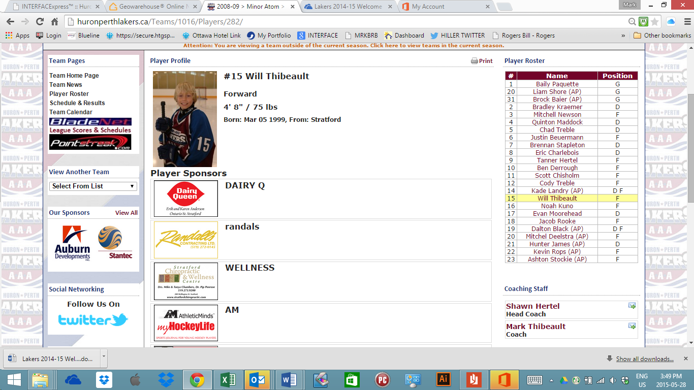

Huron-Perth Lakers “AAA” Minor Hockey Association

Date _______________________

Dear :_________________________
Please allow me to thank you for your generous sponsorship this year, in the amount of $__________. I greatly appreciate your support for the 2016-17 Hockey Season!! You can follow my team’s progress throughout the year by visiting the Lakers’ website, www.huronperthlakers.ca. On our site you can also find my team’s schedule, so if you’d like to attend a game you can find out where and when. Admission to all our games is free!
Thanks again!
Sincerely,
With Our Thanks,
Pete Young
Huron-Perth Lakers Pete Young, President
AAA Player Huron-Perth Lakers AAA Minor Hockey Association

www.huronperthlakers.ca
P.O. Box 1052, 75 Waterloo St.
Stratford, Ontario

Team Banner 2016-17

This year's team sponsor banners will require you to send in a file type of the following.

1. EPS Best Quality
2. PDF Better Quality
3. JPEG HIgh ressoulution(200 mb or greater)
4. PNG Lowest Quality (eg. tomslogo.eps)

Each file type listed above is in the preferred sequence and will give the best image quality to the team banner. Please request your sponsors to send you the files in the above format ASAP.
Please refrain from using a scanned business card (use this as a LAST resort) Also No one sponsor or player will be given priority on the list of sponsors.
Files will be sent to a selected team staff member that will be selected at your parent meeting.

Sample banner from Last Season
Please note: Deadline is Aug 1, 2016

